Dear Armstrong Parents and Guardians,

Summer is right around the corner. Your child has worked really hard all year long trying to bring his/her reading level up. In an effort to keep all of our students reading at their current level over the summer months, I want to inform you of all the summer reading programs. As you can see from the data below, spending just 20 minutes of reading time each day will make a dramatic difference in your child’s success in the upcoming school here.

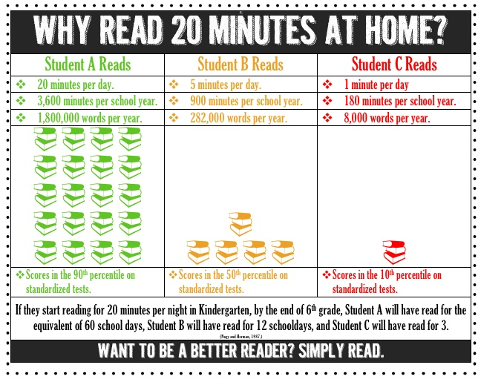

On the back, you will find information about different summer reading programs and incentives. I hope you find this information useful. I wish you and your family a very relaxing, safe, and fun-filled summer!!!

Sincerely,

Mrs. Tracy Jones

St. Louis County Library's popular summer reading clubs will kick-off June 1 and run through August 4. The library offers clubs for all ages: babies, kids, teens and adults, with fun programs and great prizes for each age group.   
  
Participation is free and registration begins June 1; simply stop by and St. Louis county Library branch to sign up.   
  
For more information please call 314-994-3300, visit the St. Louis County Library at [www.slcl.org](http://www.slcl.org), or follow the library on Facebook or Twitter.



​The St. Louis Public Library is proud to kick off its annual Summer Reading Clubs for kids and adults. This year all three clubs—kids, teens, and adults—begin on May 7 and continue through July 25.  
Readers can join at any St. Louis Public Library location. To take part, readers should register ONCE at any St. Louis Public Library location.   
  
Register online: <http://slplsr.evanced.info/>  
Each time a student completes five books, win a small prize, and keep reading! Adults need to complete 10 books for a prize.

http://www.slpl.org/images/logo.gif

The Scholastic Summer Reading Challenge™ is a free online reading program for children.   
Join today and let’s set a new reading world record for summer 2015! (May 9 - Sept 9, 2016)

**http://www.scholastic.com/ups/campaigns/src-2016**

Complete the Reading Rewards Calendar to receive 10 free tokens at Chuck E. Cheese’s.

A calendar is attached in this packet. You can print more of them off from their website: [www.chuckecheese.com/deals-offers/rewards-calendars](http://www.chuckecheese.com/deals-offers/rewards-calendars)

There are other reward calendars on their as well!! However, it says only one of these can be used at a time per child.

Go check it out!

​Kids Earn a Free Book!   
  
Step 1. Read any 8 books and record them in the [Reading Journal.](http://img1.imagesbn.com/pimages/kids/summerreading/2015/2015_Tear%20Pads-English-Spanish.pdf)  
Step 2. Bring the completed Reading Journal to your local B&N store.   
  
Step 3. Choose a FREE BOOK from our selection on the Reading Journal list at the store.

**\*\*Information is attached.**



